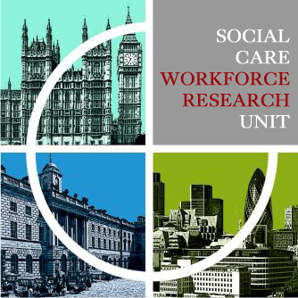   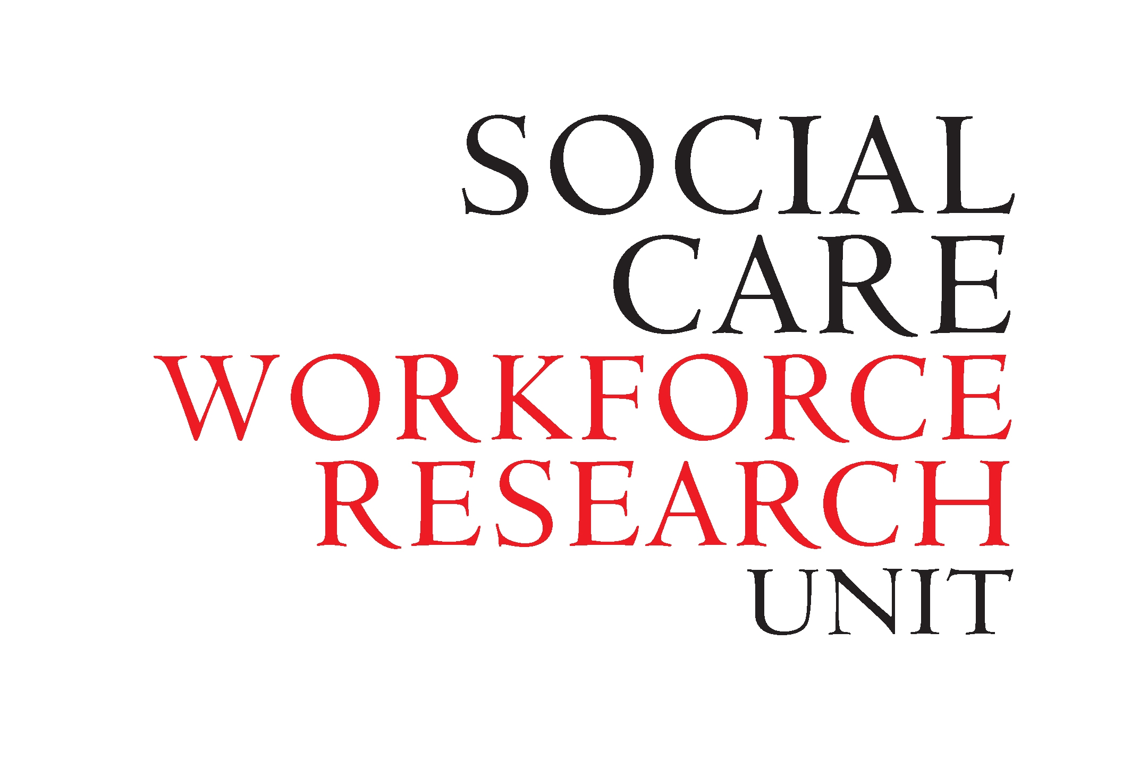

**Workforce perspectives on the care and support of older people in England**

**2018 MRC Seminar Programme** from the **Social Care Workforce Research Unit** at **King’s College London**

|  |
| --- |
| **Telecare for older people: are we getting the best out of it?**  **Wednesday 21 February**  **John Woolham, Senior Research Fellow, SCWRU, King’s College London** |
| **Outcomes of generalist day centres: more than simply social inclusion and meals**  **Wednesday 21 March**  **Katherine Orellana, Research Associate, SCWRU, King’s College London** |
| **Do social workers consider there to be an 'optimal' time for a person with dementia to move to a care home?**  **Wednesday 25 April**  **Laura Cole, Senior Research Associate, SCWRU, King’s College London** |
| **Resilience and self-care**  **Wednesday 23 May**  **Paul Goulden, Chief Executive, Age UK London** |
| **Developing Vulnerable Adult Negotiation Skills*(different venue)**  **Thursday 14 June**  **Craig Ward, CEDR accredited mediator and solicitor and SCWRU PhD student** |
| **Challenges faced and ways to cope: perspectives of the homecare workforce supporting people with dementia up to the end of life.**  **Wednesday 9th July**  **Kritika Samsi, Research Fellow, SCWRU, King’s College London & Tushna Vandrevala, Kingston University** |
|  |

Seminars take place at 2pm in the Cabinet Room on the 1st floor of the Virginia Woolf Building, King’s College London, 22 Kingsway WC2B 6LE (nearest station Holborn). * Please note that the June seminar will be in room G79, Franklin Wilkins Building, on the Waterloo campus

Tea, coffee and biscuits are provided. Seminars are free to attend but places are limited. To book a place please contact **Janet Noble at** [janet.noble@kcl.ac.uk](mailto:janet.noble@kcl.ac.uk)